**Submitted by Mohammad Fahim Nazari**

1. To run the application, load the code to your favorited IDE.
2. In the terminal type python3 KPI_tracker. python3
3. It will provide a GUI interface that you should follow.
4. to exit just press the x on the graphical user interface top right corner.
5. All the data entered by user will get stored in a text file at the same directory as the program.
6. The read data function than read that data to calculate the total percentage for the admin.

Note

The application has been debugged and tested.

Please contact me at fahim_nazari389@outlook.com if you find something that need to be updated.

The following has been added to the program.

1. The program now read the file from a text file and calculate the percentage to total assigned cases and total closed cases.

2. The program is debugged in VS code and online IDE I have provided some of the screen shot here.

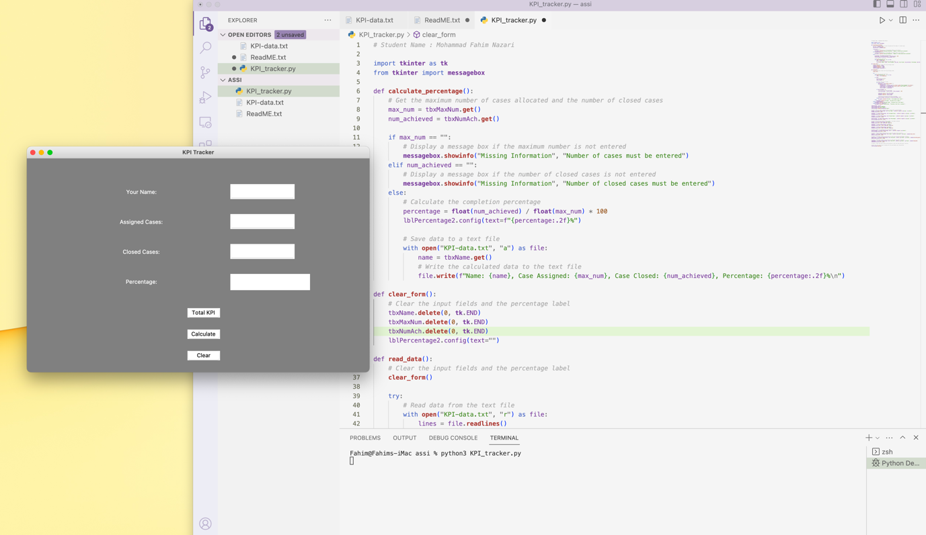

The application has running successfully and provide a GUI for the user.

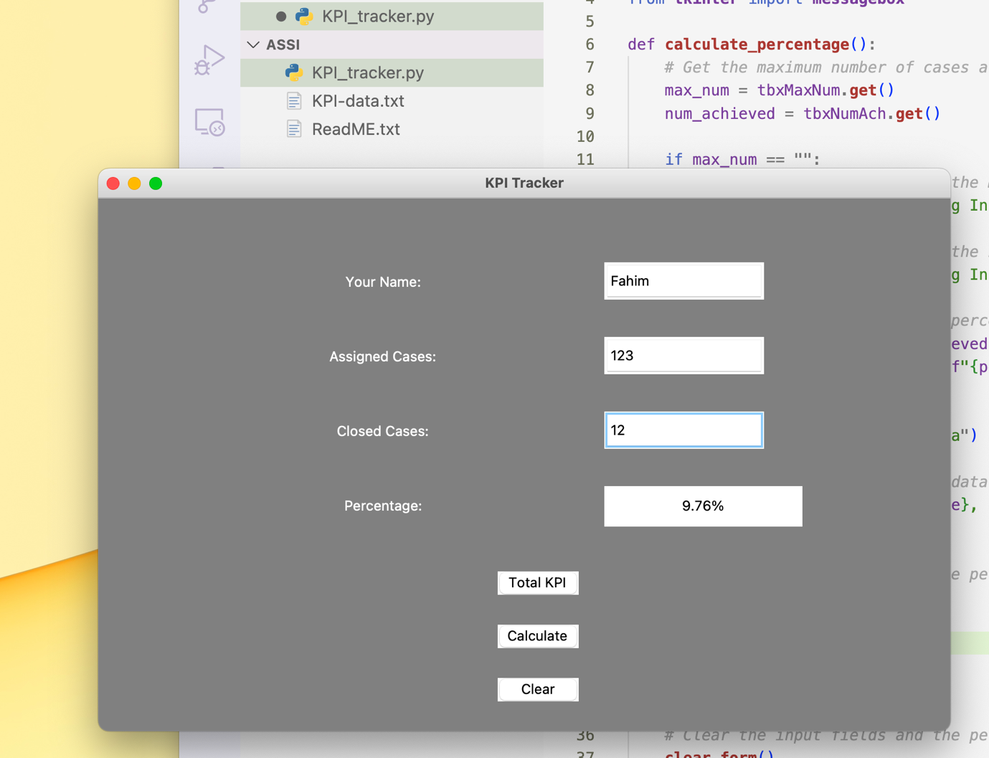

User can enter the data into the program to calculate the assigned cases vs closed cases for individual.

By pressing the total KPI the administration can understand the total cases that has been assigned and the total cases that has been completed and the percentage of total.

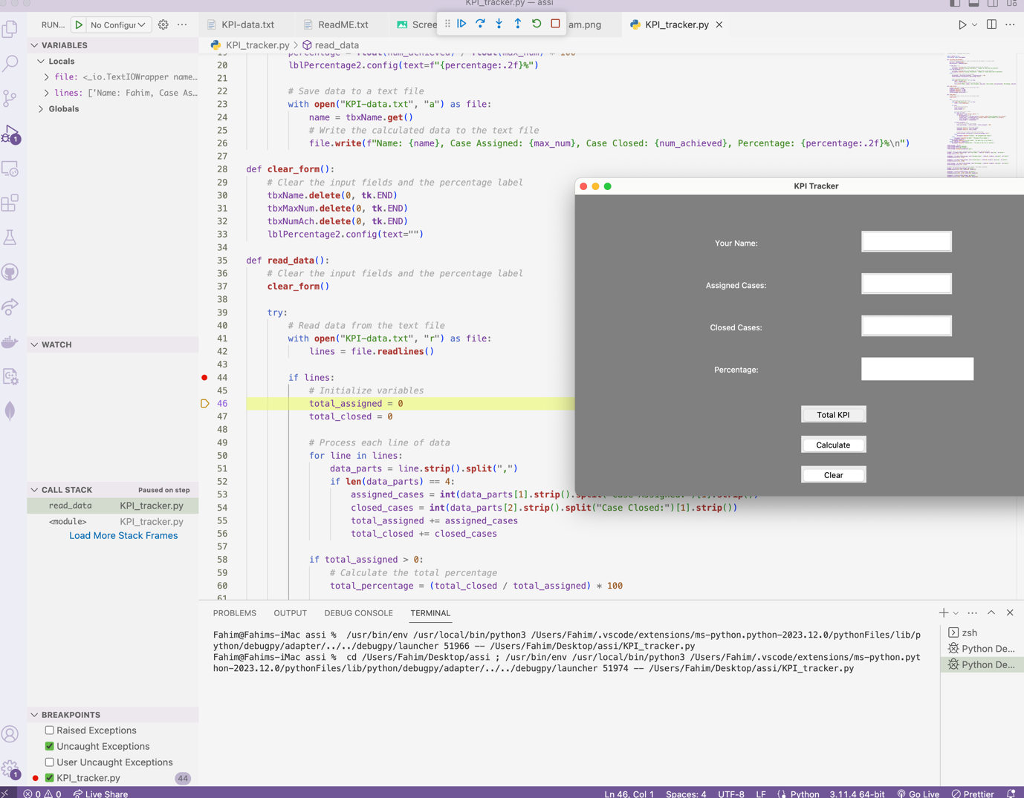

For debugging our program in VS code We can choose different break in our program and can see what happened in the program as the picture show.

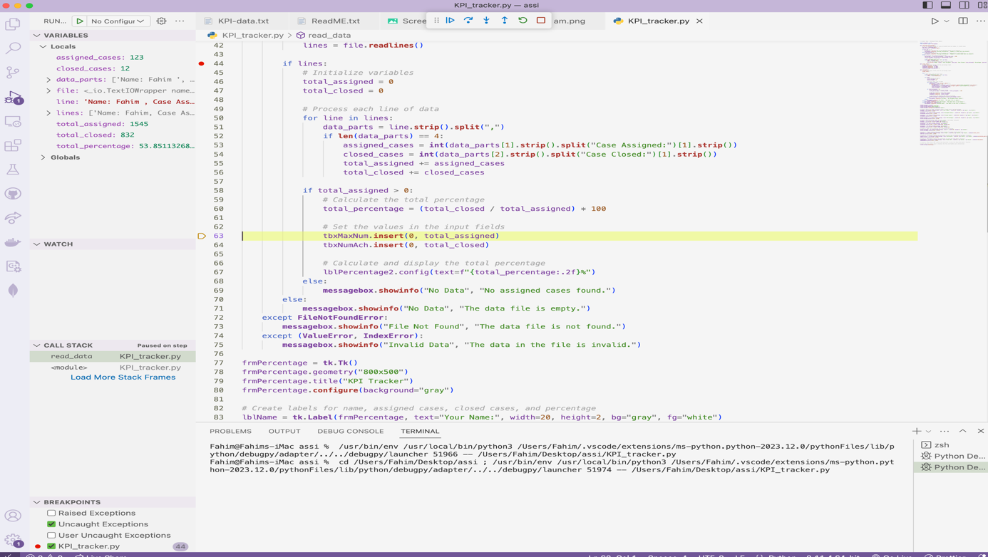

Can track each line of code step by step.

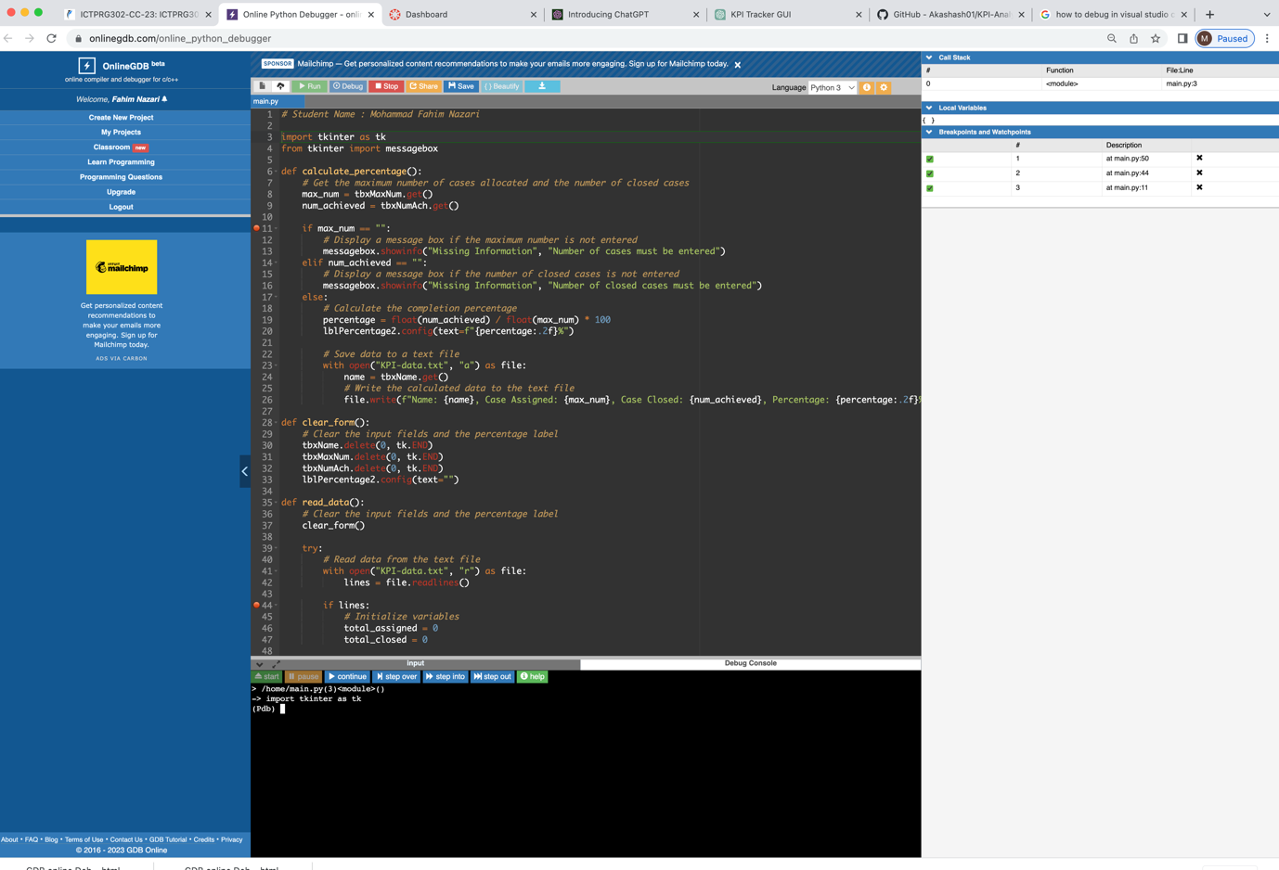

The same way we can do debugging in and online python debugger.

